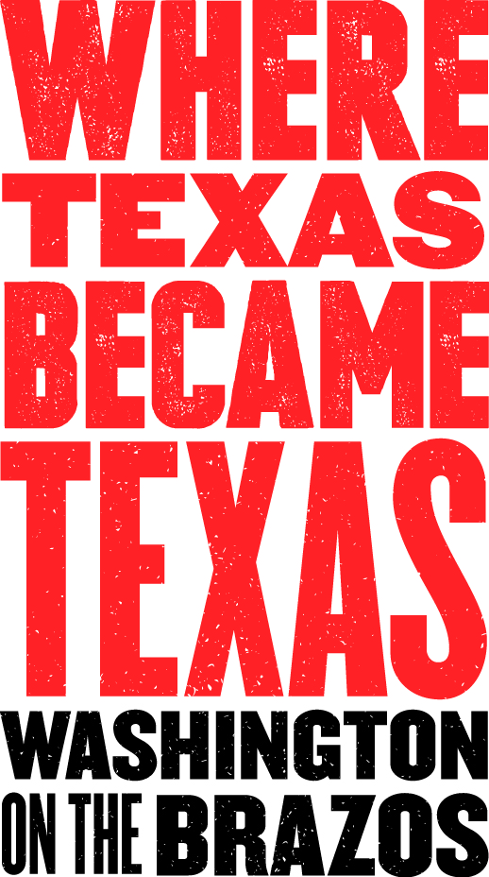
Media Contact:
Jeanne Albrecht, PR Coordinator
210-392-9047
jca@jeannebiz.com
(Please email or call for photos, advance interviews, etc.)
May 2016

For Immediate Release:
H-E-B Presents Fireworks on the Brazos

Celebrate national independence at the very site where Texas gained its independence in 1836 at Washington on the Brazos State Historic Site, between Brenham and Navasota.
Presented by H-E-B and coordinated by the Washington on the Brazos State Park Association, the annual 4th of July celebration at this 293-acre state park includes a day filled with family activities from 10 a.m. to 10 p.m. on Monday, July 4, 2016.
Highlights of the celebration are the free music concert by Cody Bryan Band from 7 to 9 p.m. in the park’s amphitheater, followed by a fireworks extravaganza with patriotic music at approximately 9:30 p.m. Tours of Independence Hall occur on the hour at 11 a.m. and 1, 2, 3, 4 and 5 p.m., along with old-fashioned period baseball games between 6 and 7 p.m. Kid's crafts will take place at the Visitor's Center from 1 p.m. to 3 p.m. Period games (such as sack races, pig bladder toss, egg on spoon races); firing of rifles with black powder demonstrations; and living history interpretations will occur at the Barrington Living History Farm. The Gift Shop will be open from 10 a.m. to 9 p.m.
Buses will run constantly from 1 to 10 p.m. to shuttle guests to the different areas of the park, at no charge.
Food and craft vendors will offer a variety of items for sale throughout the event. H-E-B will give away free sodas in the afternoon, near the Visitor’s Center. As always, admission to the park and parking is free. Fees apply for access to Independence Hall (the site in 1836 where the representatives met to write the declaration of independence); the Star of the Republic Museum (collections honoring the history, cultures, diversity and values of early Texans; administered by Blinn College); and Barrington Living History Farm (where interpreters dress, talk, work and farm as the earliest residents of the original farmstead did).
Visitors can bring picnics, blankets, lawn chairs and flashlights. State park rules apply; alcohol prohibited. Contact Jon Failor at (936) 878-2214 ext. 224 or Jon.Failor@tpwd.texas.gov for more information.
KTEX/KWHI will broadcast patriotic music to accompany the fireworks display.
This event is made possible by H-E-B, Brenham National Bank, Brenham KTEX 106 Sounds Like Texas, KWHI 1280, Del Sol Food Company-Briannas, Germania Insurance, Washington County Convention & Visitors Bureau, Texas Parks and Wildlife (TPWD), the Star of the Republic Museum/Blinn College, and the Washington on the Brazos State Park Association.
Washington on the Brazos State Historic Site is found on the Brazos River at the original townsite of Washington, Texas, a major political and commercial center in early Texas. It is located at 23400 Park Road 12, Washington, TX, 77880—approximately halfway between Brenham and Navasota, off of State Hwy. 105. From Hwy. 105, follow either FM 912 or FM 1155 to Park Road 12. For additional information, call (936) 878-2214 or visit www.wheretexasbecametexas.org.

