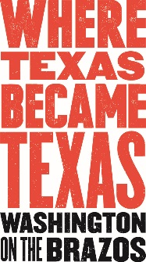
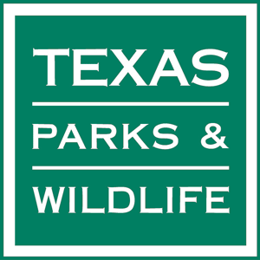
Media Contact:
Jeanne Albrecht, PR Coordinator, Sellmark
210-392-9047
jca@jeannebiz.com
May 2018

For Immediate Release:
Farmers Market at Washington on the Brazos
Next Market scheduled for Saturday May 19

Washington on the Brazos State Historic Site is holding Farmers Markets from 10 a.m. to 2 p.m. under the live oak trees outside the park’s Visitor Center every third Saturday, from April through July. Local vegetables, fruits, snacks from food trucks, baked goods, artisan items and more will be sold at this free event, sponsored by the Washington on the Brazos State Park Association. The market will also offer visitors educational opportunities about sustainable local food and farming practices.

The markets will be held rain or shine since vendors can move inside. Parking and admission to the park are free, as always.

“Our first Farmers Market in April was a huge success, even with the threat of rain,” says Celeste Doty, Assistant Gift Shop Manager, Washington on the Brazos. “The local community really showed their support so the ‘farmers’ and all the vendors were very happy with the visitation. Many commented on how nice it was to shop for homemade or homegrown products and visit the park’s wonderful grounds and amenities, in one trip.”

The Farmers Markets are held on the same day as the park’s “Living History Saturday” event from 10 a.m. to 4:30 p.m., where staff and volunteers dress in period clothing to bring to life the people and events of the 1830s. Living History Saturday presents a unique opportunity for the entire family to discover various aspects of life during the Republic of Texas.

Some vendors include Scott Family Farm from Anderson, TX (Texas eggs and pasture fed pork and beef); Busy Bee Apiary and Apothecary (honey, handmade soaps and lotions); Land of Milk and Honey Vegetable Farm, LLC from Navasota, TX (Texas seasonal produce); Nonny’s Niche from Hempstead, TX (restored furniture, repurposed barn wood and old window décor); JD Woodworks from Plainview, TX (woodcrafts); Jimmy Jams from Pasadena, TX (homemade jams and pickles); Debbie Wellmann (homemade baked goods and jellies); Barbara Kmeic (homemade linens); Eppler Farms (eggs); Wolff Family Farms (seasonal produce and fresh cut flowers); and food trucks, The Flava Trailer from Brenham, TX (hamburgers, chicken wings, French fries and snow cones) and Thai Cowboy (spring rolls, noodle dishes). A Master Naturalist from the Texas Master Naturalist program will offer an education booth and kids activities.

For the May 19 Farmers Market, Martha Ann Hartzog, author of “Courage, Charm and Character,” will be on-site for a brief presentation and book signing from 10 a.m. to 2 p.m. inside the Visitor Center. “Courage, Charm, and Character” describes the lives of the First Ladies, the two women Governors of Texas, and other prominent women with deep ties to Texas such as Marietta Garner, Mamie Dodd Eisenhower, Lady Bird Johnson and Barbara Bush.

Contact Celeste Doty at 936-878-2214 ext. 230 or Celeste.doty@tpwd.texas.gov for more information. Updates on all WOB festivities are continually posted at www.wheretexasbecametexas.org and Facebook page at https://www.facebook.com/washingtononthebrazos/.

Farmers and vendors interested in participating should also contact Celeste Doty at 936-878-2214 ext. 230, or Celeste.doty@tpwd.texas.gov.

WHEN: 10 a.m. to 2 p.m. on Saturdays: May 19, June 16 and July 21, 2018

WHERE: Washington on the Brazos Visitor Center, 23400 Park Road 12, Washington, TX, 77880—approximately halfway between Brenham and Navasota, off of State Hwy. 105. From Hwy. 105, follow either FM 912 or FM 1155 to Park Road 12.

MORE: Washington on the Brazos State Historic Site—a TPWD-run state park—has many onsite amenities open daily, as well as an incredible schedule of events and programs. On-site attractions include Independence Hall; the Star of the Republic Museum (administered by Blinn College) and Barrington Living History Farm. The site’s Visitor Center features interactive exhibits which present a timeline of the Texas Revolution and houses the spacious Washington Emporium Gift Shop. Entrance to the park grounds, Visitor Center and parking is always free.

