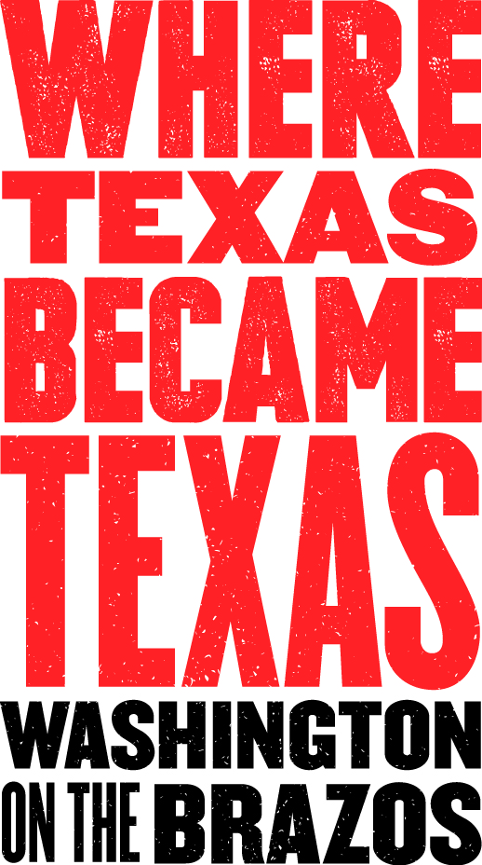
Media Contact:
Lydia Duncombe, PR Coordinator
210-824-9474
lduncombe@sellmarkusa.com
(Please email or call for photos, videos, advance interviews, etc.)
October 2019

For Immediate Release:
Holiday events and hours for Washington on the Brazos State Historic Site
Twilight Firelight and Candlelight Christmas events are highlights of the season
Brenham, TX - For those who want to “unplug” from the modern-day holiday madness and experience Texian festivities from the mid-1800s, Washington on the Brazos is the place. In addition to its rich interactive experiences and its steady schedule of living history events held year-round, two holiday events are especially magical: Twilight Firelight and Christmas on the Brazos. Twilight Firelight occurs the Saturday of Thanksgiving weekend at Fanthorp Inn State Historic Site; Christmas on the Brazos occurs the first Friday and Saturday of December at Washington on the Brazos State Historic Site. Both include frontier festivities, period music, visits with interpreters and candlelit venues (more details below).
In addition, Washington on the Brazos and Fanthorp Inn are open most of the Thanksgiving and Christmas holiday weekends. NOTE: Fanthorp Inn is only open year-round on Saturdays and Sundays from 9 a.m. to 3:30 p.m.
Thanksgiving Weekend: Washington on the Brazos (including Star of Republic Museum, Independence Hall and Barrington Living History Farm) is closed on Thursday, November 28, 2019 for Thanksgiving Day; all reopen on Friday morning for the weekend. Christmas and New Year’s Day: Washington on the Brazos State Historic Site is closed Tuesday, December 24 and Wednesday, December 25. The Star of Republic Museum will close Tuesday, December 24 and will reopen January 2, 2020.
HOLIDAY HIGHLIGHTS:
November 16, 2019 – Holiday Market: 10 a.m. – 2 p.m. (Visitor Center Complex): Jump start your holiday shopping with Washington on the Brazos's Handmade Holiday Market. Sponsored by the Washington on the Brazos State Park Association, the market will be held in the Conference Center from 10am to 2pm with 35+ craft and food vendors and live music. This will replace our third Saturday Farmer's Market. For more information or to become a vendor contact Celeste Doty at 936-878-2214 x230.

November 30, 2019 - Twilight Firelight: 4:30 p.m. – 7 p.m. (Fanthorp Inn): Looking for something to do with the family after Thanksgiving? Why not travel back in time and discover the 1850s at Fanthorp Inn! Twilight Firelight brings the old stagecoach inn to life. Visitors enjoy the ambiance of the candlelit inn, period music, dancing, mule-drawn stagecoach rides and reenactors clad in period attire. Inns like Henry Fanthorp’s were places where news from far away was spread, ideas were exchanged, and communities developed. Activities begin at the Grimes county courthouse in Anderson where visitors board a replica stagecoach or wagon for a ride down Main Street to Fanthorp Inn. Upon arrival visitors will step off the coach and into 1850 as the soft glow of a candle flickers in the parlor window and the sound of fiddle fills the air. The atmosphere of the inn and living history personalities brings the holiday season to life.
- Texas Historical Commission presents Twilight Firelight at Fanthorp Inn to you without admission fees but with a suggested donation of Adults -$10.00 and Students (12 and under) $5.00.
- No reservations are required.
- Tickets will be available beginning at 4:30 p.m. the day of the event near the Anderson Courthouse parking area where the stagecoach and/or wagon rides to the Inn will begin.
- Please dress appropriately for the season and be prepared for the weather as the event will take place in a period setting with some portions outdoors.
- The first floor of the Inn as well as the Barn/Restrooms are accessible.

December 6 & 7, 2019 – Christmas on the Brazos: 4:30 p.m. – 8 p.m. (Park Grounds): Walk the candlelit paths at Barrington Plantation and experience a Texas Christmas in the decade before the Civil War. Discover the origins of some of our favorite holiday traditions as costumed interpreters bring to life the festivities of the season with musket-fire, music, dancing and more! Tour the historic home of the last President of the Republic, Dr. Anson Jones, as the family enjoys their Christmas gathering. Visit the farm’s quarters to hear how the enslaved at Barrington celebrated the season. Sip a hot cup of cider, cozy up to the fire and begin your holiday season with Washington on the Brazos State Historic Site. All visitors park and purchase tickets at the Visitor Center and Gift Shop. $10 Adults and $5 for Students (12 and under). Wagon ride will take you to Barrington where your experience will begin.This is a special program at the Plantation. Contact Barb King at 936-878-2214 x246.
- No reservations are required
- Please dress appropriately for the season and be prepared for the weather as the event will take place in a period setting with walking and some portions outdoors.

SCHEDULE OF OTHER SPECIAL EVENTS – NOV THROUGH DEC 2019:

November 2 & 3, 2019 – Holiday Foods at Home: 10 a.m. – 4 p.m. (Barrington Plantation): What special foods do you enjoy at the holidays? Like you, the Jones family hosted visitors and enjoyed a varied diet full of exotic treats to mark the season. We’ll be making a few of these foods this weekend and talking about many others. This is a special focus weekend. Discussions and kitchen activities ongoing. Contact Barb King at 936-878-2214 x248.

November 9 & 10, 2019 – Labor of Thine Hands: 10 a.m. – 4 p.m. (Barrington Plantation): Ponder for a moment all of the skills and trades practiced by others that you rely upon daily: auto mechanics, carpenters, electricians, plumbers just to name a few! Just as you need skilled laborers to live, so too did the farmers of early Texas. Join us at Barrington Farm where demonstrators will exhibit some of the many skills needed by our ancestors. Hear the ringing of the blacksmith’s hammer, get your hands dirty as you help mold bricks, help a surveyor measure with his chain or watch a potter turn clay into vessels. Experience history as it comes to life before your eyes! This is a special program at the plantation. Contact Ben Baumgartner for more information at 936-878-2214 x248.

November 16 & 17, 2019 – 19th Century Medicine: 10 a.m. – 4 p.m. (Barrington Plantation): Before becoming president, Anson Jones made his fortune as a doctor. At a time when medicine was more art than science, what would a visit to the doctor be like? Come take a peek behind the curtain with us at Barrington as we uncover the tricks and tools of the trade. This is a special focus weekend. Contact Barb King for more information at 936-878-2214 x248.

November 16, 2019 – Living History Saturday: 10 a.m. – 4 p.m. (Independence Hall): Travel back in time to where a nation was born in 1836. On the third Saturday of each month, staff and volunteers dressed in period clothing bring to life the people and events of Old Washington providing a unique opportunity to discover various aspects of life surrounding the birth of the Republic of Texas. The program features activities suited for the entire family. Try your hand at writing with a quill pen and sign a copy of the Texas Declaration of Independence. Visit with militia soldiers travelling through town or try your hand at some early Texas games. Step back in time and discover the spot where Texas became Texas! (Activities will vary, and some are weather dependent.) This program will feature: Quill Pen Writing, Texas Militia Equipment, and 1800’s Style Printing Press. Contact Adam at (936) 878-2214 ext. 228

November 16, 2019 – Runaway Scrape Escape Room: 10 a.m. – 4 p.m. (Star of the Republic Museum): After his victory at the Alamo, Santa Anna and his army are on their way, you must quickly determine what to take on your journey and make your way to safety with the help of your friends and family. In the newest program at the Star of the Republic Museum, participants must use teamwork and problem-solving skills to decipher puzzles and riddles in order to get out of the room in the 45-minute time limit. “Runaway Scrape Escape” will be open on the third Saturday of each month through May. The escape room is opened to ages 10 and up and is designed for families or a group of children in cooperation with at least one adult. Admission is $15 for adults, $13 for students ages 18 and under, and $10 for Blinn employees and students. Advanced registration is recommended, although walk-ups are accepted based on availability. For more information or to make a reservation, visit www.starmuseum.org/calendaror call 936-878-2461.

November 23 & 24, 2019 – Turning Up and Going Fallow: 10 a.m. – 4 p.m. (Barrington Plantation): Dr. Jones penned in his journal on Nov. 16, 1846 – “Recommenced breaking up the strip of prairie on the east side of field…” As the crop growing season wanes and the fields go fallow, we’ll turn over the fields once more before winter sets in. Come see our strong oxen at work, and try your hand at walking behind a plow! This is a special focus weekend. Contact Ben Baumgartner for more information at 936-878-2214 x248.

December 14 & 15, 2019 – Cooking at the Quarters: 10 a.m. – 4p.m. (Barrington Plantation): Enslaved men and women, such as Jerry, Mary, Willis, and Jake, were an integral part of the full story of Barrington. Cooking a hot meal after a hard day of work was a daily routine and typically included their ration of cured pork and cornmeal supplemented with seasonal vegetables from their garden. Come join us as we demonstrate cooking a traditional meal in the style of enslaved foodways using period ingredients and methods. This is a special focus weekend. Contact Ben Baumgartner for more information at 936-878-2214 x248.

December 21 & 22, 2019 – Holiday Foods: 10 a.m. – 4 p.m. (Barrington Plantation): What special foods do you enjoy at the holidays? Like you, the Jones family hosted visitors and enjoyed a varied diet full of exotic treats to mark the season. We’ll be making a few of these foods this weekend and talking about many others. This is a special focus weekend. Discussions and kitchen activities ongoing. Contact Barb King at 936-878-2214 x248.

December 21, 2019 – Living History Saturday: 10 a.m. – 4 p.m. (Independence Hall): Travel back in time to where a nation was born in 1836. On the third Saturday of each month, staff and volunteers dressed in period clothing bring to life the people and events of Old Washington providing a unique opportunity to discover various aspects of life surrounding the birth of the Republic of Texas. The program features activities suited for the entire family. Try your hand at writing with a quill pen and sign a copy of the Texas Declaration of Independence. Visit with militia soldiers travelling through town or try your hand at some early Texas games. Step back in time and discover the spot where Texas became Texas! (Activities will vary, and some are weather dependent.) This program will feature: Quill Pen Writing, Texas Militia Equipment, and 1800’s Medicine. Contact Adam at (936) 878-2214 ext. 228

December 28 & 29, 2019 – Horse High, Bull Strong and Hog Tight: 10 a.m. – 4 p.m. (Barrington Plantation): Dr. Jones noted in his journal on Dec. 29, 1847 – “Hired Mr. Bowen… Sent Him with two hands to Cedar Brake to make rails.” With the main crop fields turned fallow, now is the time to repair and restack fencing around the farm. Come help us clear and build up our fences so that they’ll be ready to defend the new crop in spring. This is a special focus weekend. Contact Ben Baumgartner for more information at 936-878-2214 x248.

Washington on the Brazos State Historic Site
It was March 2, 1836 when 59 delegates bravely met at Washington, Texas to make a formal declaration of independence from Mexico. From 1836 until 1846, the Republic of Texas proudly existed as a separate nation. Washington on the Brazos is, indeed, “Where Texas Became Texas.”
Washington on the Brazos State Historic Site has many onsite amenities and is open daily, as well as an incredible schedule of events and programs. On the grounds of this 293-acre, Texas Historical Commission-run site is Independence Hall (the site in 1836 where the representatives met to sign the declaration of independence); the Star of the Republic Museum (collections honoring the history, cultures, diversity and values of early Texans; administered by Blinn College); and Barrington Plantation (where interpreters dress, work and farm as the earliest residents of the original farmstead did). The site’s Visitor Center features interactive exhibits which present a timeline of the Texas Revolution and highlight the historic attractions located within the park; it also houses the spacious Washington Emporium Gift Shop, which offers snacks and a wide range of Texas-themed items and keepsakes. The entrance to the park grounds, Visitor Center and parking is always free; fees apply for access to Barrington Plantation and the Star of the Republic Museum, and guided tours of Independence Hall.
Leashed pets are allowed in the park, but NOT allowed onto Barrington Plantation or in the buildings. Attractions are accessible. For lodging information, please contact the Brenham Visitor Center at www.visitbrenhamtexas.com/ or the city of Navasota at www.navasotagrimeschamber.com.
Washington on the Brazos State Historic Site is located at 23400 Park Road 12, Washington, TX, 77880—approximately halfway between Brenham and Navasota, off of State Hwy. 105. From Hwy. 105, follow either FM 912 or FM 1155 to Park Road 12. For additional information, call (936) 878-2214 or visit the Park Association’s website at www.wheretexasbecametexas.org or Facebook.

