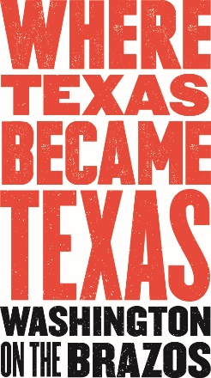
Bark in the Park
September 25, 2021
10am-2pm
Washington on the Brazos State Park

Sponsorship Opportunities
Sponsorship opportunities

WHAT: Bark in the Park
Share a beautiful day at the park with your four-legged friends while social distancing! Visitors are invited to bring their dog (on a leash) to the Washington on the Brazos State Historic Site. There will be educational booths, adoption information and pet products for sale as well as animal demos. Entertainment and food will be available. Water will be provided for the pets. All vendors and demonstrations are outside and will be sufficiently separated apart as to help with social distancing. Attendees are encouraged to wear masks when social distancing cannot be achieved.

WHEN: Saturday, September 25, 2021
Park Gates open 8 a.m. to sundown.
Event will take place 10 a.m. to 2 p.m.

COST: Entrance to the park and event are free. Proceeds from the event will go to the Historical Foundation and its educational programming and maintenance of the extensive 293-acre park.

Dogs are not allowed inside the Museum, Barrington Plantation, Visitor’s Center or Independence Hall. Regular Admission fees will be collected for these.

WHERE: Washington on the Brazos State Historic Site
23400 Park Rd 12
Washington, TX 77880

CONTACT: Lydia McAfee
marketing@wheretexasbecametexas.org
210-824-9474

Sponsorship Opportunity: $1,000 to $25

Sponsorship Benefits:

$1,000 Grand Champion
- Exclusive Title Sponsor designation on all materials.
- Prominent recognition during the event.
- Special signage around park.
- Logo on advertisements placed.
- Spotlight on website, social media.
- Vendor Space to fit your needs.
- Logo listed in program & signage.

$500 Blue Lacey
- Presenting Sponsor designation on all materials (limit to three).
- Prominent recognition during the event.
- Special signage around park.
- Logo on advertisements placed.
- Spotlight on website, social media.
- Vendor Space to fit your needs.
- Logo listed in program & signage.

$250 Great Dane
- Prominent recognition during the event.
- Special signage around park.
- Name listed in media release and calendar announcements.
- Logo on advertisements placed.
- Spotlight on website, social media.
- 10x10 Vendor Space, tent provided upon request.*
- Logo listed in program & signage

$100 Labrador
- Name listed in media release.
- Logo on advertisements placed.
- Logo on website, social media
- 10x10 Vendor Space, tent provided upon request.*
- Logo listed in program & signage.

$50 Beagle
- Name listed on website, social media.
- 10x10 Vendor Space.
- Name listed in program & signage.

$25 Dachshund
- 10x10 Vendor Space.
- Name listed in program & signage.

Rescue Organization Free
- Name listed in program, signage, website, social media, and media release.

In-Kind Sponsorships can be negotiated.

* Limited quantities available. First come first serve basis.

