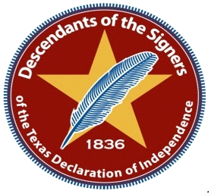

Dear Descendant of a Signer of the Texas Declaration of Independence,
For nearly 5 years the committee for the signers has been holding gathering at Washington on the Brazos State Park on a date closest to March 2nd , the signing of the Texas Declaration of Independence. The Star Museum has located nearly 9000 live descendants by genealogy research. The new Bronze Medallion will not only help raise needed funds for more genealogy research but funds to pay for future gatherings. The medallion will give each descendance something beautiful and very honorable to be displayed or can be placed on the graves of their deceased family descendant. Only persons proved to be a descendant can order this medallion.
In order to get the price break we need for the fundraiser we must order at least 100 or more at a time. I will place this order by November 15th. The order takes 8 to 10 weeks for delivery. I will not place another order until after the first of the year.
Our event this March 3rd, 2018 will be a luncheon. Senator Lois Kolkhorst has agreed to be our key note speaker. Please put the dates of March 2nd,3rd and 4th on your calendar. An amount for the luncheon will be posted soon. We will be holding an auction and raffle at the luncheon and on line.
Please use the attached form and follow instructions. Thank you for supporting our fundraiser and helping preserve our Texas History.
God Bless Texas!
Amber Folk/Committee Chair of the Descendants
truetexas59@gmail.com

