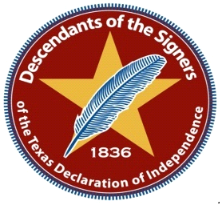
Order Form for Descendants Medallion
Descendant Name:
_________________________________________________________
Address___________________________________City______________________
State___________ Zip____________ Phone______________________ Email_________________________________
Signers Name_______________________________________________________
Verified as a Descendant by: ______________________ Date________________
Number Ordered _____X $60.00 = _________
Shipping Fee ($8.50) per 1 = _________ Total Fee = _________
Make all checks or Money Orders payable Washington on Brazos State Park Association
Please Print Order From. Fill out form, make you a copy and mail with payment to:
Amber Folk
Turn around time for delivery will take 8 to 10 weeks after order is received
If you would like to have company ship directly to you please include $8.50
The medallion is being used as a fundraiser for the Descendants Committee to use for payment of future descendant’s events, research to locate more descendants, and possible scholarships for descendants.

8538 Laurel Trails Dr.
Houston, TX 77095
Phone 713-505-4250
Email: truetexas59@gmail.com

